ASSIGNMENT 4

CLOUD APPLICATION DEVELOPMENT

|  |  |
| --- | --- |
| Student Name | Aakash K |
| Team Id | PNT2022TMID38912 |
| Maximum Marks | 2 Marks |

1. Pull an Image from docker hub and run it in docker playground. The image is built.

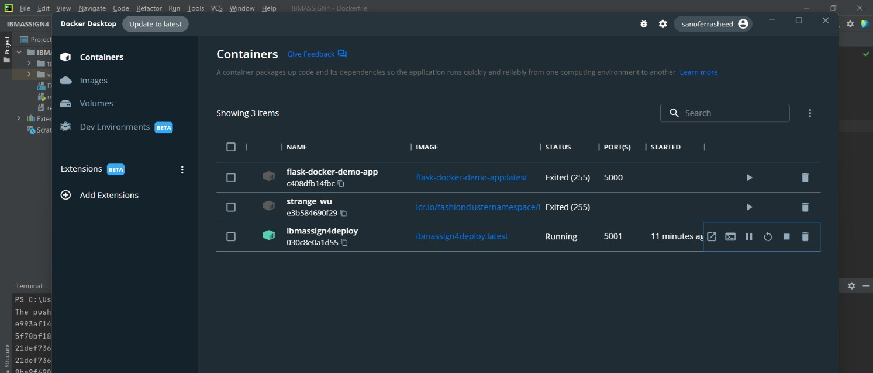

The same image is pushed to docker hub using the command

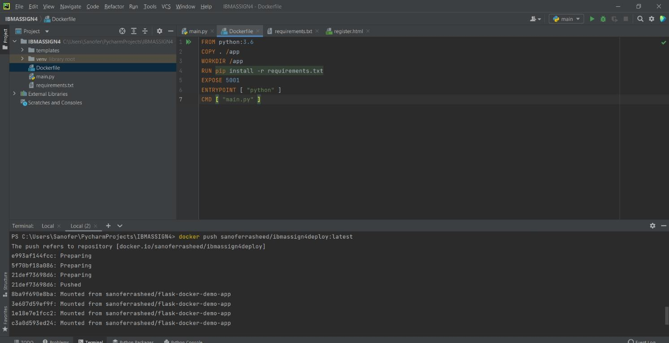

Here image name is ibmassign4deploy. Thus it is pushed in docker hub.

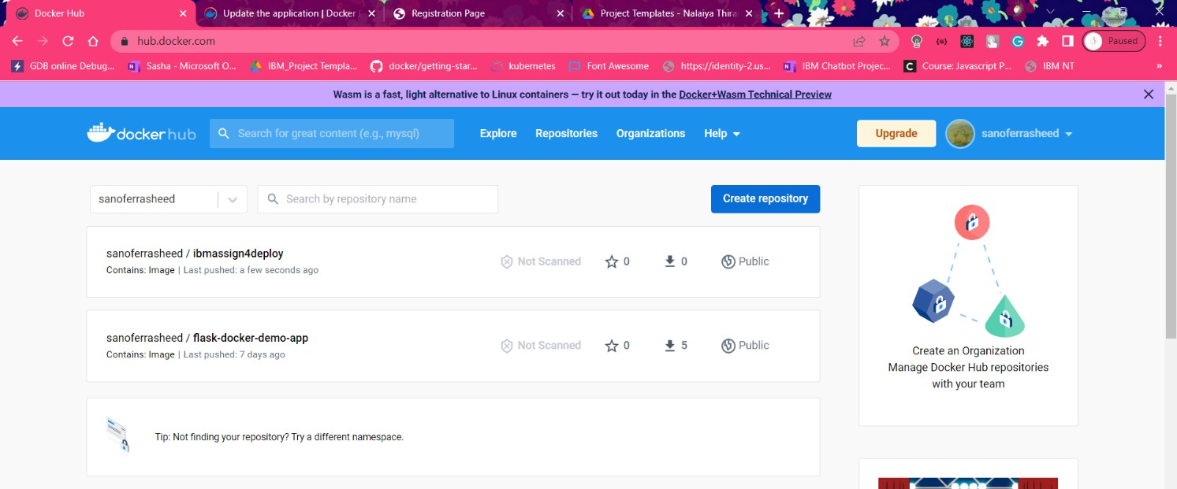

The app is running at the specified port.

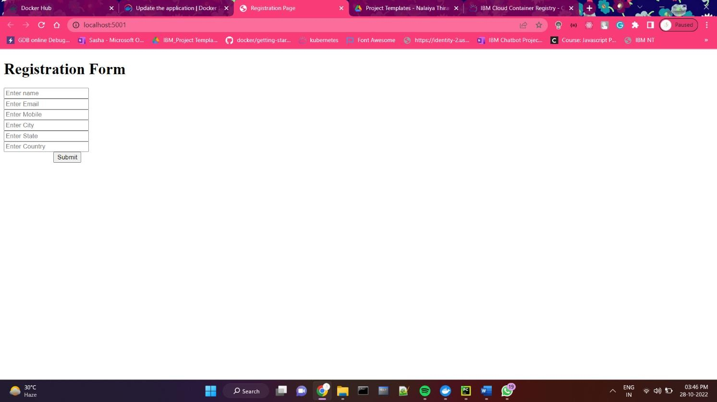

1. Create a docker file for the application and deploy it in Docker desktop application. Dockerfile:

FROM python:3.6 COPY . /app WORKDIR /app

RUN pip install -r requirements.txt EXPOSE 5001

ENTRYPOINT [ "python" ] CMD [ "main.py" ]

Thus docker file created and deployed in docker desktop.



1. Create a IBM container registry and deploy hello world app. Container registry created using

* docker tag sanoferrasheed/ibmassign4deploy:latest icr.io/ibmassign4namespace/ibmassign4repo:latest
* docker push icr.io/ibmassign4namespace/ibmassign4repo:latest

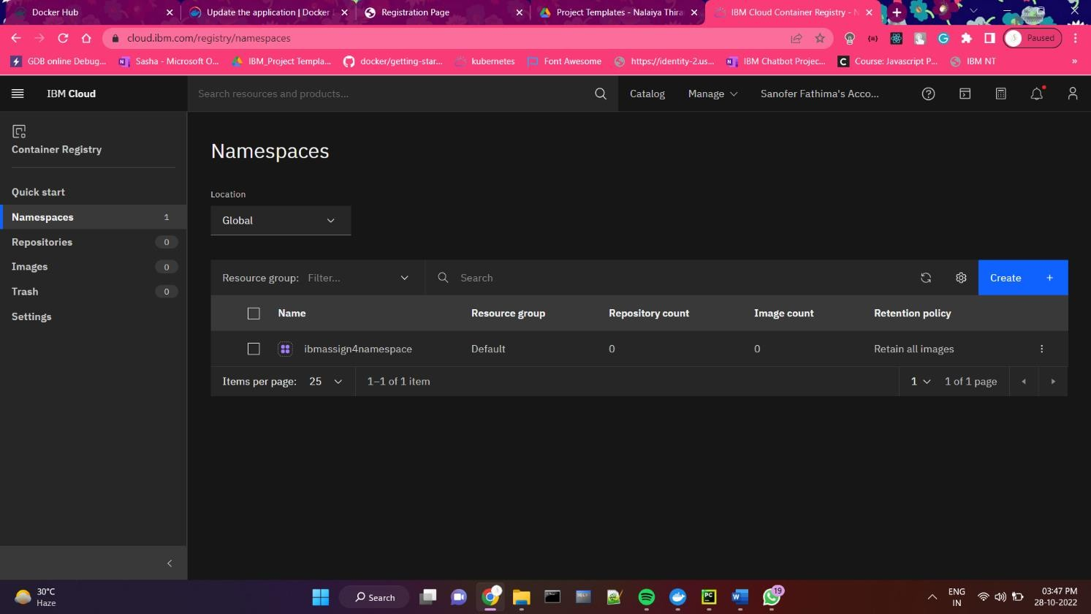

Thus, images in container registry are listed

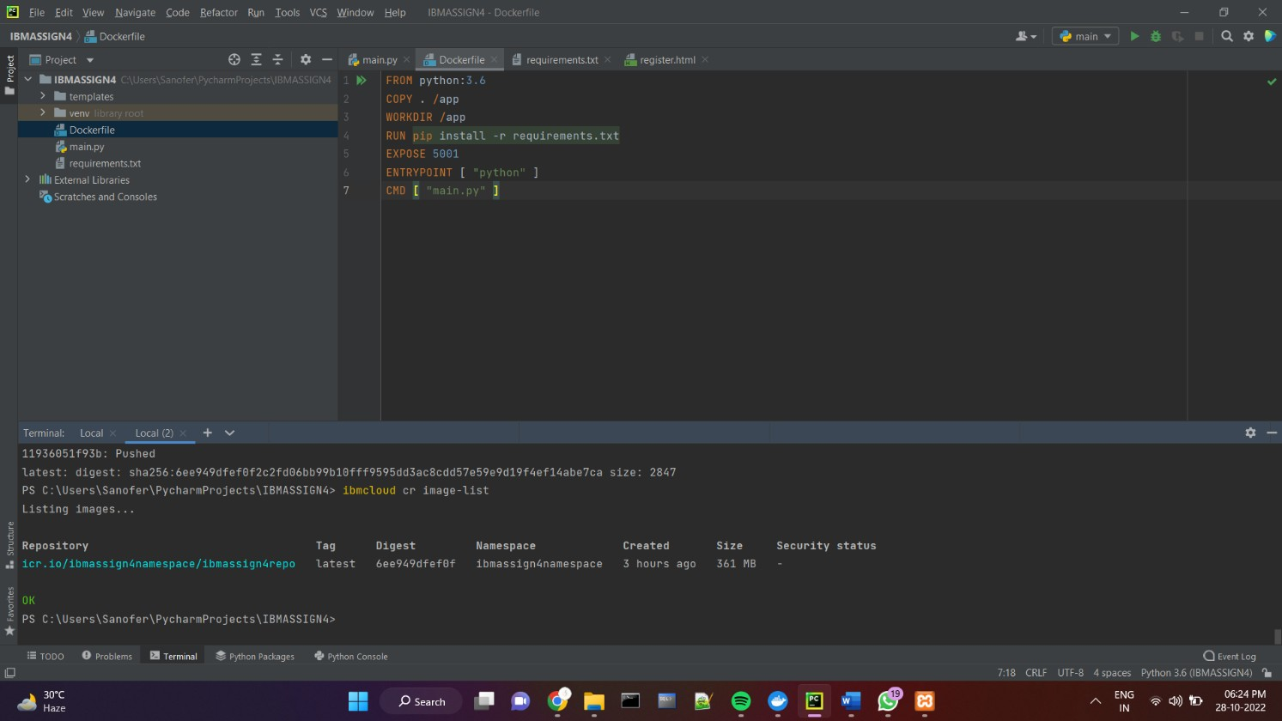

1. Create a Kubernetes cluster in IBM cloud and deploy hello world image or job portal image and also expose the same app to run in node port.

Thus, cluster is created.

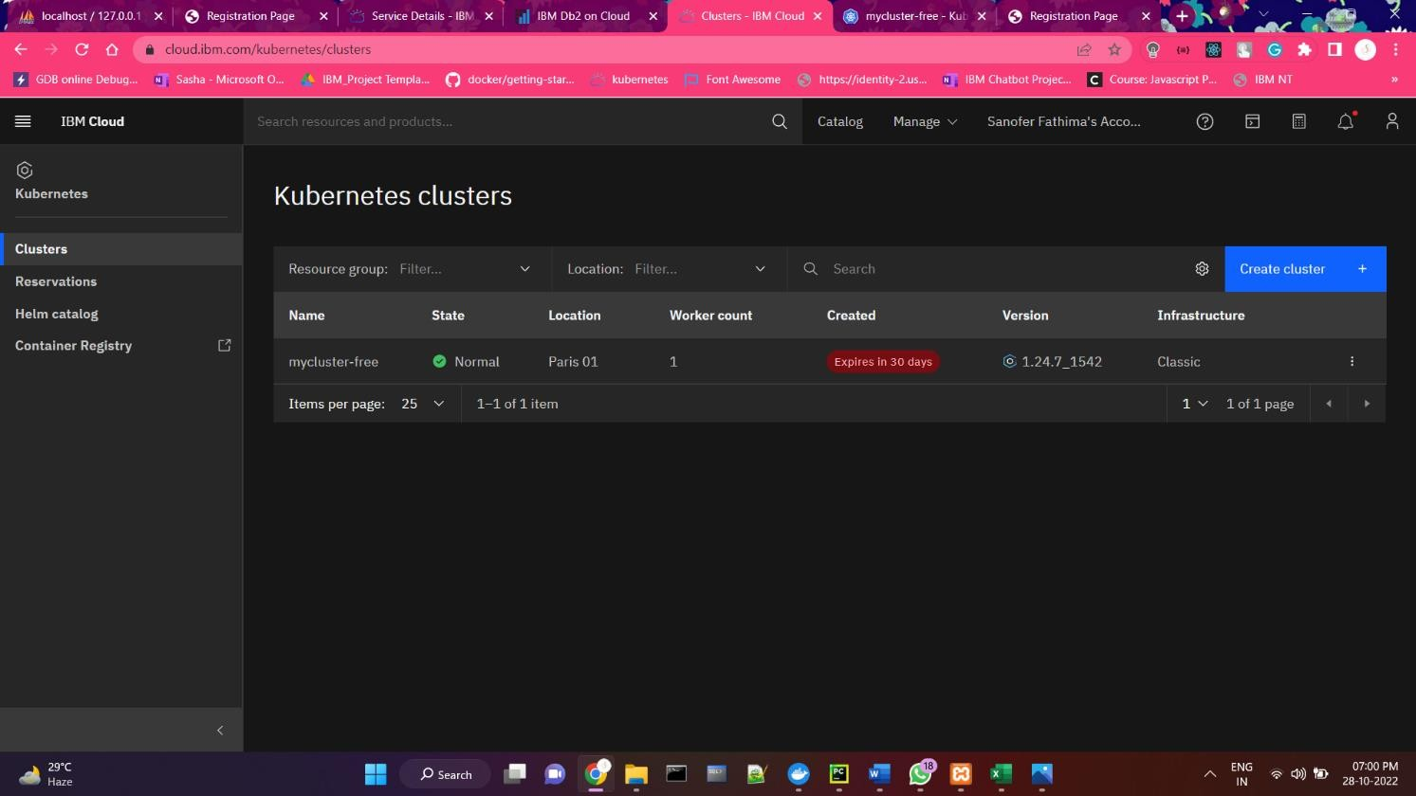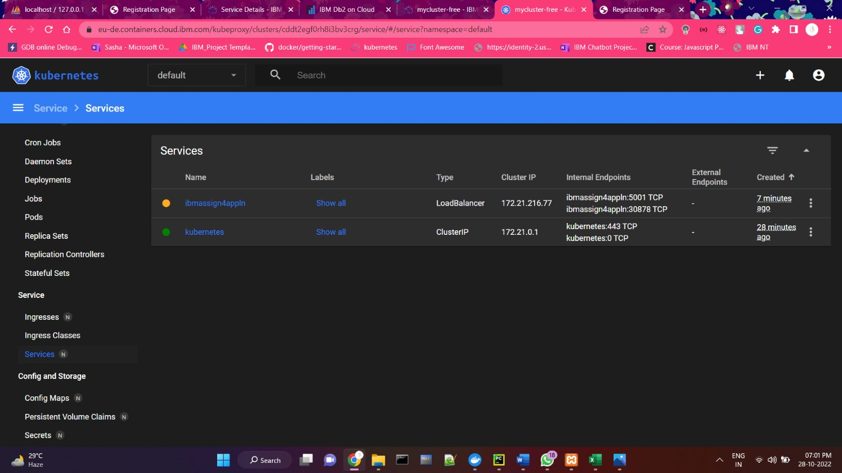

APP IS LIVE AT http://159.122.174.152:30878/